2017中国工程机器人大赛暨国际公开赛（RoboWork）

机器人搬运工程

技术报告

参赛学校： 三峡大学

队伍名称：

参赛队员：

带队教师： （附联系方式）

二〇一七年五月

关于技术报告使用授权的说明

本人完全了解2017中国工程机器人大赛暨国际公开赛（RoboWork）关于保留、使用技术报告和研究论文的规定，即：参赛作品著作权归参赛者本人和比赛组委会共同所有，比赛组委会可以在相关主页上收录并公开参赛作品的设计方案、技术报告以及参赛机器人的视频、图像资料，并将相关内容编纂收录在组委会出版论文集中。

参赛队员签名：

带队教师签名：

日 期：

目 录

目录

0 引言/综述 5

1. 系统整体设计 5

1.1

2机械结构设计 5

2.1小车整体效果图**……………………………………………………………………………………..**5

2.2机械设计整体论述**……………………………………………...…………………………………...**5

3硬件设计 6

3.1小车电路逻辑流程图**…………………………………………...…………………………………...**6

3.2小车电路接线图**……………………………………………...……………………………………...**7

3.3主要硬件介绍**……………………………………………...………………………………………...**8

4软件设计 11

4.1算法策略**……………………………………………...…………………………………………….**11

4.2程序流程框图**……………………………………………...……………………………………….**12

4.3程序源代码**……………………………………………...……………………………………….....**13

5系统开发与调试 53

6结论 54

**标题[1]**

**李宝万，李四2**

(三峡大学，湖北省 宜昌市 443002; 三峡大学，湖北省 宜昌市 443002)

**摘要：**机器人使用两个带编码器的直流电机、四个迷你舵机一个Arduino2560控制板、直流电机驱动板和稳压板模拟工业自动化过程中自动化物流系统的作业过程。机器人从起点出发在比赛场地内移动，将不同颜色但相同形状的物料分类搬运到设定的目标区域最后在回到出发位置。

**关键词：**机器人；颜色分类；物料搬运

Title in English

ZUO Zheyi1，ZUO Zheer2

*（School of Automation, Xi’an University of Posts and Telecommunications, Xi’an* 710000*, China;*2. *Department of Computer Science, Shaanxi Normal University, Xi’an* 710061*, China)*

**Abstract：**Robot using two dc motor with encoder, four mini steering gear a Arduino2560 panel, dc motor to drive the clamp plate and stability simulation automatic logistics system in the process of industrial automation process.Robot from the start to move inside the venue, will be the same shape but different color of the material classification to the target area the last in the back to the starting position.

**Key words：**Robot；color classification；materials handling：

# 引言/综述

我们研究的内容是搬运机器人制作、编程、和精确完成；随着教育事业的要求和社会工业化的提高，机器人的制作逐渐进入模块化，程序的编写也变得公式化，工业生产最后迫切需要的是机器人在完成任务时的精确表现。我们研究的目的是在比赛组委会设定的比赛规则下，在最短的时间内，使搬运机器人制作更加精致、编程更加简约、操作任务更加精确地完成比赛任务。我们采用的搬运方式首先对应的是A、C、E三个位置的物块，首先将这三个位置的物块都抓在特殊爪子下，然后调整物块的位置，将这三个物块拖到相应的颜色区；对于F、G两处的物块堆，我们小车是逐个抓取一个物块堆的物块，逐个将其放置在目标位置附近再进行码垛。

# 系统整体设计

小车采用四轮驱动，这个优点是：有足够的动力，承载我们的车载硬件，使我们小车在更短的时间内完成比赛；经过四轮车的测试、调节，发现其中还有一些技术（四轮同时传动）有待攻克。最后我们选择了带编码器的双轴电机，这样使得一侧的两个轮子可以保持相同的速度。用了八个模拟灰度传感器，前面两个用于预判，夹子下面的四个用于巡线，车身的两个用于在中心检测黑线。对于物块的堆放，使用夹子的结构，夹子用3D打印而来，固定在滑块上，可以随滑块在垂直导轨上上下移动，两侧采用了两个钩子用于到两个物料区将物块一个一个勾出来，每个钩子用了两个迷你舵机，提供两个方向的自由度。根据比赛规则，以及硬件的设计布局，完成各个子程序的设计再搭配算法 和主逻辑完成整个小车的软件设计。

# 2机械结构设计

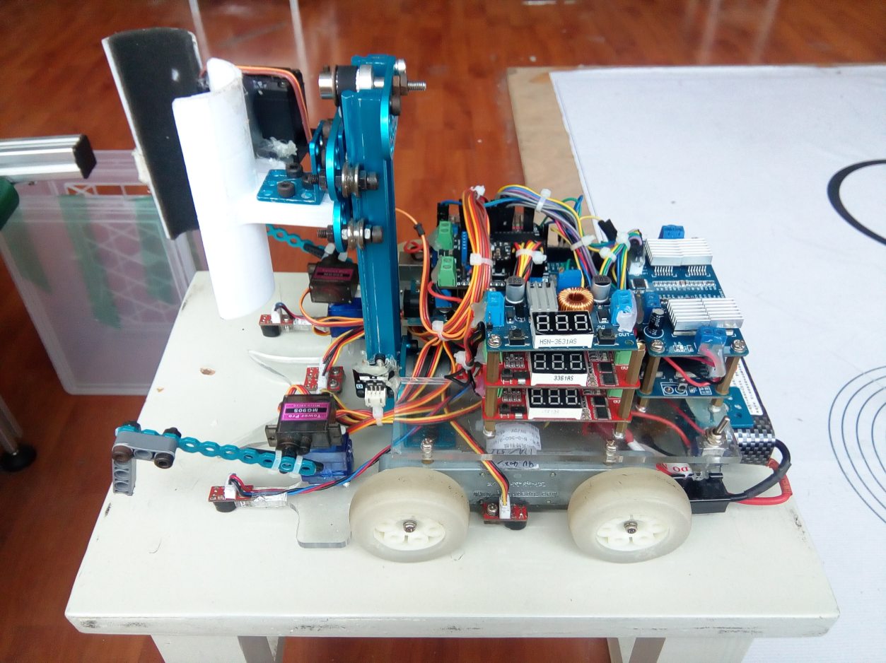**2.1小车整体效果图：**

**2.2机械设计整体论述**

为了确保小车行走的精度，我们根据小车行走的路线地图，我们使用了8个模拟灰度传感器、自带编码器电机等硬件设备。这也只是电子硬件设备；我们的机械硬件设备是用乐高积木、MakBlock金属积木、、亚克力塑料板，塑料导柱和金属导柱等材料硬件设备。

小车机械设计原则是：尽量保证车身尺寸符合比赛要求，最大化的减少车体重量，各个硬件的安装布局遵循不影响小车的重心，使小车的重心位于四个车轮的对角线交点，尽可能的保证车身的最大灵活性、机动性及平稳性，方便后期程序的调试。

我们小车的底板及上层支撑板是用重量减轻的亚克力板做成的，由于导轨和电机与车板连接的折弯件没有塑料零件加工经验，所以只好用金属件，导轨、导轨与夹子的连接件和钩子用的是MakBlock金属积木，钩子前端选用的是乐高积木。为了最大程度保证车身的稳定性，我们将体积较小的电子硬件灵活安装在车身的上面，用塑料导轨及螺母来规划和确定各个电子硬件的位置，因为前面夹子及标准舵机的重量较重，所以我们将较重的电子硬件，电池安排到车子的尾端，确保车身的行走稳定。

# 3硬件设计

**3.1小车电路逻辑流程图：**

小车行走信息来源：触角灰度传感器、巡线灰度传感器、编码器读值、逻辑程序的执行。小车行走控制中心：Arduino 2560控制板。小车行走输出设备：电机运转、升降电机运行、舵机执行。

**Arduino2560控制板**

升降电机运行

舵机运行

**小车驱动电机运转**

**3.2、电路接线图**

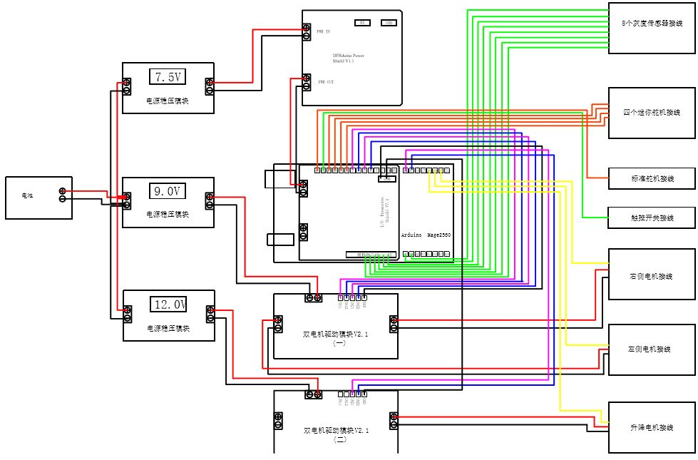

**3.3、主要硬件介绍**

该作品使用的控制板是Arduino Mage2560控制板，配套使用了一块DFRduino Power Shield V1.1电源稳压板、I/O Expansion Shield V7.1扩展板、一个5A电源稳压板、两个2A电源稳压板、两个MOS双电机驱动模块、两个纳英特双轴电机、一个带编码器的直流电机、四个MG90S迷你舵机、一个1501MG标准舵机、8个灰度巡线传感器，具体硬件参数如下：

3.3.1、 Arduino Mage2560控制板

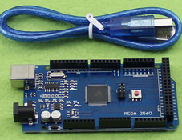

1）概括介绍

Arduino Mega2560是采用USB接口的核心电路板，具有54路数字输入输出，适合需要大量IO接口的设计。处理器核心是ATmega2560， 同时具有54路数字输入/输出口（其中16路可作为PWM输出），16路模拟输入，4路UART接口，一个16MHz晶体振荡器，一个USB口，一个电源 插座，一个ICSP header和一个复位按钮。Arduino Mega2560也能兼容为Arduino UNO设计的扩展板。Arduino Mega2560已经发布到第三版，与前两版相比有以下新的特点：

在AREF处增加了两个管脚SDA和SCL，支持I2C接口；增加IOREF和一个预留管脚，将来扩展板将能兼容5V和3.3V核心板。

改进了复位电路设计。

USB接口芯片由ATmega16U2替代了ATmega8U2。

2）供电方式

Arduino Mega2560可以通过3种方式供电，而且能自动选择供电方式

外部直流电源通过电源插座供电[1] 。

电池连接电源连接器的GND和VIN引脚。

USB接口直接供电。

电源引脚说明[1]

VIN --- 当外部直流电源接入电源插座时，可以通过VIN向外部供电；也可以通过此引脚向Mega2560直接供电；VIN有电时将忽略从USB或者其他引脚接入的电源。

5V --- 通过稳压器或USB的5V电压，为UNO上的5V芯片供电。

3.3V --- 通过稳压器产生的3.3V电压，最大驱动电流50mA。

GND --- 地脚。

3）输入输出

1.14路数字输入输出口：工作电压为5V，每一路能输出和接入最大电流为40mA。每一路配置了20-50K欧姆内部上拉电阻（默认不连接)。[1]

除此之外，有些引脚有特定的功能：

4路串口信号：串口0---0(RX)and 1(TX);串口1---19(RX)and 18(TX);串口2---17(RX)and 16(TX);串口3---15(RX)and 14(TX)。其中串口0与内部 ATmega8U2 USB-to-TTL 芯片相连，提供TTL电压水平的串口接收信号。

6路外部中断：2(中断0)，3(中断 1)，18(中断 5)，19(中断 4)，20(中断 3)，and 21(中断 2)。触发中断引脚，可设成上升沿、下降沿或同时触发。

14路脉冲宽度调制PWM（0--13）：提供14路8位PWM输出。

SPI（53(SS)，51(MOSI)，50(MISO)，52(SCK)）：SPI通信接口。

LED（13号）：Arduino专门用于测试LED的保留接口，输出为高时点亮LED，反之输出为低时LED熄灭。

2.16路模拟输入：每一路具有10位的分辨率（即输入有1024个不同值），默认输入信号范围为0到5V，可以通过AREF调整输入上限。除此之外，有些引脚有特定功能：

TWI接口（20（SDA）和21（SCL））：支持通信接口（兼容I2C总线）。

3.AREF：模拟输入信号的参考电压。

4.Reset：信号为低时复位单片机芯片。

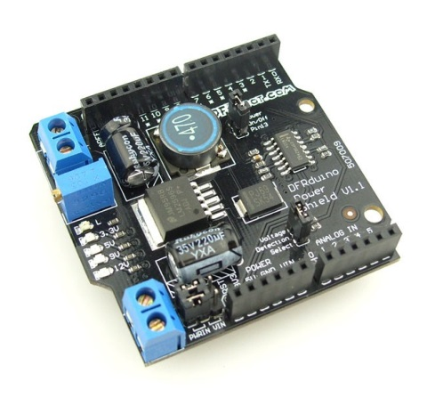3.3.2、DFRduino Power Shield V1.1电源稳压板

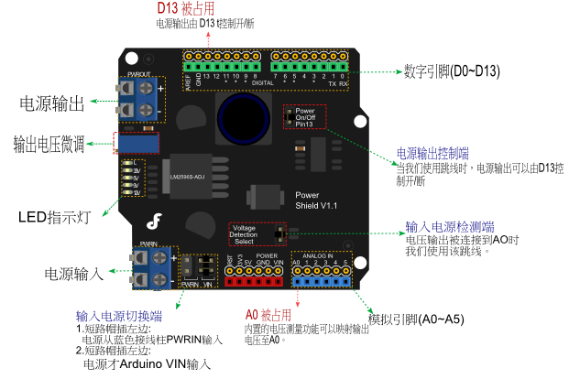

1）概括介绍

Arduino叠层式可调稳压模块，发热量低，效率高，输出电压1.25－12V可调。只要您的输入电压在4.5－35V以内，就可以随意调节1.25－12V的输出电压，比如需要给5V的舵机供电，则可把输入端接在12V电池上，调节输出微调电位器，使5V指示灯亮起，这时输出电压为5V。该模块非常适用于机器人中的舵机云台供电。Power Shield模块具有一个电源输入端、一个电源输出端、一个输出电压微调电位器、一个输出控制端、一个电压检测端、一个输入电源切换端、一组LED指示灯。

2）技术参数

．模块性质：非隔离降压模块（buck）

．输入电压：4.5-35V

．输出电压：连续可调1.25-12V

．输出电流：额定电流2A，峰值3A

．转换效率：最高90%（输出电压越高，效率越高）

．开关频率：150KHz

．工作温度：工业级（-40℃到 +85℃）（输出电流1A 以内）

．满载温升：40℃

．负载调整率：±1%

．电压调整率：±0.5%

．动态响应速度：5% 200uS

．短路保护：限流，自恢复

3.3.3、I/O Expansion Shield V7.1扩展板

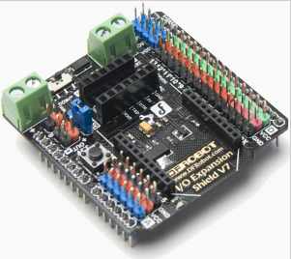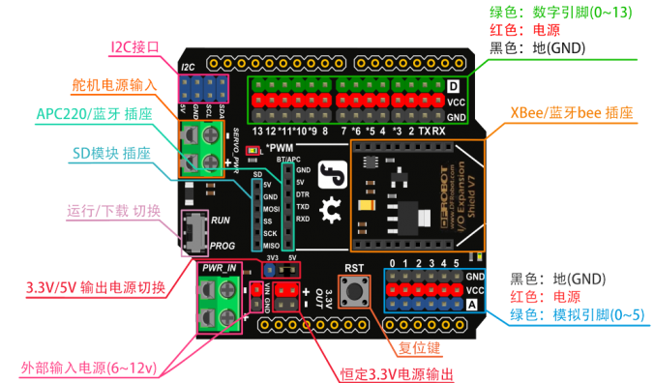

1）技术参数

把Arduino的端口扩展成3P接口，直插3P传感器模块。14个数字口（6个PWM口），

6个模拟口。

丰富的通信和存储模块接口。中部直插Xbee封装的蓝牙、WIFI和Xbee通信模块。旁边

设置了普通蓝牙模块、APC和SD卡的扩展接口。

外部电源扩展，为你的Arduino作品提供持久续航。扩展板角落接线柱为主控器和扩展

板供电，中部接线柱为数字口上的舵机供电。

5.5V的时候提供3.3V的供电，兼容更多3.3V的元件。

2）使用说明

运行/下载 切换：新版的扩展板增加了“运行”与“下载代码”的切换键。下载代码时，

拨到“PROG”档。运行时，拨到“RUN”档。用过V5的用户可能会知道，V5版的扩展板，我们在使用XEee这些通讯模块的时候，由于串口使用冲突，所以每次下载程序都需要把通讯模块拔下，下载完代码后重新插上模块。V7扩展只需要拨动这个按键就可以了，无需重复插拔通讯模块。

3.3V/5V输出电源切换：跳帽可以用于选择输出电源是5V或者3.3V。便于给需要3.3V

电源的传感器供电。如果没有该跳冒，VCC引脚输出电压为0。

恒定3.3V电源输出：这个电源输出与其他VCC引脚的输出电压有所不同，其他引脚的VCC是与前面电源跳冒选择有关的，而这里则不是，是恒定的3.3V输出电压。

外部输入电源(6~12V)：提供了可外部输入电源的接口，上图可看出，外部输入有两种接口可选择，但输入电压都是控制在6~12V。

舵机电源输入(5~12V):可给数字引脚外部供电5~12V,1.数字引脚接入设备较多，比如在一些机器人的搭建平台中，使用了多个舵机，导致因电流过小而无法正常工作的情况。就可在该接口外接5V电源来补充电流; 2.当数字引脚接入了需要较大电源的器件，可在该接口直接外接5~12V电源。

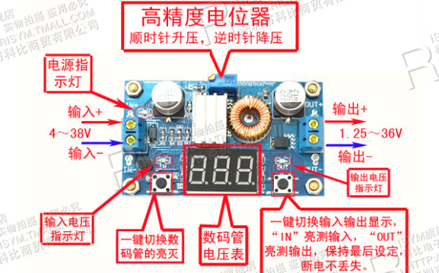 3.3.4、5A电源稳压板

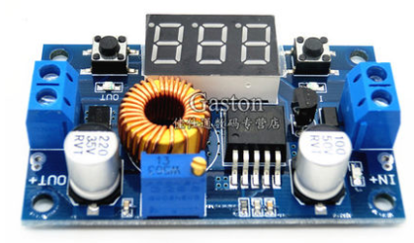

1. 技术参数

输入电压4.0~38V连续可调。（输入电压比输出电压高1.5V）

输出电流可达5A，建议在4.5A内使用

输出功率可达75W

转换效率可达96%

1. 使用说明

板载电压表显示输出电压时，长按右侧按键2秒后松开，电压表和输出电压指示灯“OUT”同步闪烁，此时进入输出电压调整模式：同理，在电压表显示输入电压时，长按右侧

3.3.5蓝宙双电机直流电机驱动模块

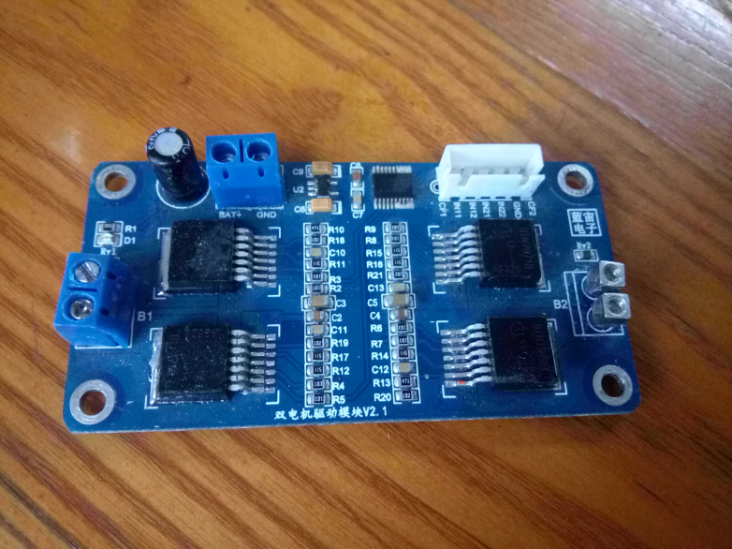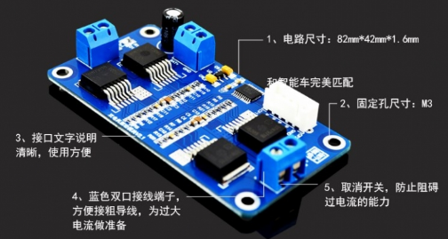

1）技术参数

一路电机驱动输出，单板典型最大电流 68A，最小在 50A；

增加总线驱动芯片 74LVC245，提高信号驱动能力，同时隔离 BTN7971 和单片机， 保护 BTN7971 和单片机芯片，防止 BTN7971 损坏后将电池电压直接输入到单片机，进而 烧坏单片机控制引脚；

增加 MIC5219 电源芯片，为总线驱动芯片 74LVC245 提供电源，实现驱动芯片和 单片机电平匹配。。

驱动板工作电压范围：7V~14V；最大不能超过 16V；

电机工作频率范围：0~25KHz;推荐驱动频率范围：3KHz~8KHz；

驱动板子工作温度范围：-10°~55°，BTS7971 工作温度范围：-40°~150°， 实际使用中控制芯片最大温度不要超过 105°；

# 4软件设计

**4.1、算法策略**

我们小车使用的编程环境是开源软Arduino：Arduino 是一款便捷灵活、方便上手的开源电子原型平台，包含硬件（各种型号的arduino板）和软件（arduino IDE)。

程序编写的方式：从搬运小车光电工程组的规则可以看出，在这种比赛规则下，在比赛时可以组成的任务类型有很多很多种。一开始我们也很苦恼，难道我们要编写很多很多的程序，来应对这种种的可能吗？根据老师的提示及我们观察分析小车完成任务的动作及路径，我们想出了一个对应各种情况的万能的程序。程序分析：小车从一开始出发到圆心，然后再此转一个对应的角度，到达某一个地方，然后又回到中心，接着又转一个角度，去某一个方向又回来。这就是一组又一组的重复性。我们设定特定的一些变量去确定这些转角，把总的任务分成三个小模块，三个小模块的动作也有重复性，然后小模块中就有了更小的子模块，还有子子模块等，这些模块也同时对应了相应的子程序，这样我们的程序就变得简单化和模块化。然后在我们的主程序里去合理的调用这些模块，就能很简单的完成相应的功能了

分析比赛规则可知，参赛队伍通过抽签方式，从五种颜色中确定A,B,C,D,E对应物块颜色顺序，第一环节取A,C,E放到地图上内部圆环上的空白小圆A,C,E处，第二环节将F区物料堆的五个颜色物料推到对应颜色区域,五个小环标记ABCDE.第三环节将G区物料堆的另五个颜色物料推到对应颜色区域,五个小环标记ABCDE，由此，我们得到灵感，写一个算法，只要输入抽到的五种物块颜色顺序，即可产生小车在图纸中心位置的旋转角度，使小车能够将物块推到对应颜色区域。

经过分析发现转角存在递推关系，递推公式next_angle=F_X-last_angle+4，next_angle为小车在图纸中心位置向下一个颜色目标区域转向的相对转角数，F_X为小车车头指向下一个颜色目标区域时的相对于主方向的绝对转角数，last_angle是小车上次推物块到相应颜色目标区域的绝对转角数

**4.2、程序逻辑框图**

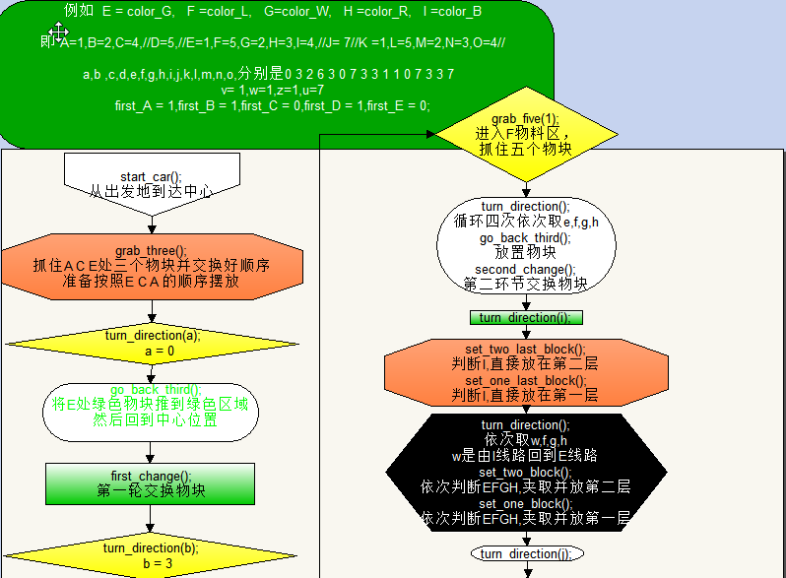

**4.3、程序源代码**

int a,b,c,d,e,f,g,h,i,j,k,l,m,n,o,p,q,r,s,t,u,v,w,z;//向下一个颜色目标区域转向的相对转角数

int A,B,C,D,E,F,G,H,I,J,K,L,M,N,O,P,Q,R,S,T,U;//小车上次推物块到相应颜色目标区域的绝对转角数

int first_A = 0,first_B = 0,first_C = 0,first_D = 0,first_E = 0;

int chou_qian_1,chou_qian_2,chou_qian_3,chou_qian_4,chou_qian_5;

int F_h = 7;//G物料区

int F_g = 6;//出发区

int F_f = 5;//F物料区

int F_G = 4;//绿色

int F_W = 3;//白色

int F_R = 2;//红色

int F_B = 1;//黑色

int F_L = 0;//蓝色

char color_G=1, color_W=2, color_R=3,color_B=4, color_L=5;

int F_f_4=6,F_h_10=7,F_e_16=8;

int vel_left_x=92,vel_left_s=84,vel_right_x=104,vel_right_s=94;

int step_flag = 0;

int step_car = 0;

int step_turn=0;

#include <Servo.h>

Servo myservo_left_x;

Servo myservo_left_s;

Servo myservo_right_x;

Servo myservo_right_s;

Servo myservo_front;

int servo_touch=12;//控制舵机触控开关

//舵机引脚

int left_1 = 6;

int left_2 = 7;

int right_1 = 4;

int right_2 = 5;

int front_1 = 14 ;

int front_2 = 15;

//灰度传感器

int a_1,a_2,b_1,b_2,b_3,b_4,c_1,c_2;

//电机编码器

long count_left,count_right,count_front;

int left = 5,right = 4,front=2;

int claw_1 = 160, claw_2 = 100, claw_3 = 71;

int up_1 = 240 ,up_2 = 445;

void setup()

{

chou_qian_1 = color_R, chou_qian_2 = color_G ,chou_qian_3 = color_L , chou_qian_4 = color_B , chou_qian_5 = color_W;

A = chou_qian_5 , B = chou_qian_3 , C= chou_qian_1 ;

D = F_f_4;

E = chou_qian_2 , F = chou_qian_1 ,G = chou_qian_3 , H = chou_qian_5 , I = chou_qian_4;//B A C E D

J =F_h_10 ;

K = chou_qian_1 , L = chou_qian_2 , M = chou_qian_5 , N = chou_qian_3 , O = chou_qian_4; // B A E C D

R =F_e_16 ;//第三环节结束后，回到出发地转角

Serial.begin(9600);

pinMode(servo_touch, INPUT);//触控开关为输入模式

myservo_left_x.attach(8);

myservo_left_s.attach(9);

myservo_right_x.attach(10);

myservo_right_s.attach(11);

myservo_front.attach(13);

//////////////////////////定义舵机引脚输出////////////////////////////////

pinMode(left_1, OUTPUT);

pinMode(left_2, OUTPUT);

pinMode(right_1, OUTPUT);

pinMode(right_2, OUTPUT);

pinMode(front_1, OUTPUT);

pinMode(front_2, OUTPUT);

attachInterrupt(left, Code_left, FALLING);//中断打开

detachInterrupt(left);//中断关闭

attachInterrupt(right, Code_right, FALLING);

detachInterrupt(right);

attachInterrupt(front, Code_front, FALLING);

detachInterrupt(front);

digitalWrite(left_1,LOW);//初始两个电机都处于停止状态

digitalWrite(left_2,LOW);

digitalWrite(right_1,LOW);

digitalWrite(right_2,LOW);

////////////////////////////定义舵机初始角度///////////////////////////////

myservo_left_x.write(vel_left_x);//大,外

myservo_left_s.write(vel_left_s);//大,上

myservo_right_x.write(vel_right_x);//大,中

myservo_right_s.write(vel_right_s);//大,下

myservo_front.write(160);//大,大178,82,112

}

//////////////////////////////////////////编码器中断函数////////////////////////////////////

void Code_right()

{

count_right += 1; // 编码器码盘计数加一

}

void Code_left()

{

count_left += 1;

}

void Code_front()

{

count_front += 1;

}

////////////////////////////读取灰度传感器的数值并判断//////////////////////////////////

void get_value()

{

a_1=(analogRead(A8)>=400? 0:1);

a_2=(analogRead(A9)>=400? 0:1);

b_1=(analogRead(A0)>=403? 0:1);

b_2=(analogRead(A1)>=850? 0:1);

b_3=(analogRead(A2)>=500? 0:1);

b_4=(analogRead(A3)>=676? 0:1);

c_1=(analogRead(A4)>=841? 0:1);

c_2=(analogRead(A5)>=830? 0:1);

///////////////////////////////串口监视器打印判断后的数值//////////////////////////////////

Serial.print(a_1);

Serial.print("\t");

Serial.print(a_2);

Serial.print("\t");

Serial.print(b_1);

Serial.print("\t");

Serial.print(b_2);

Serial.print("\t");

Serial.print(b_3);

Serial.print("\t");

Serial.print(b_4);

Serial.print("\t");

Serial.print(c_1);

Serial.print("\t");

Serial.println(c_2);

Serial.print("\t");

//////////////////////////////串口监视器打印灰度传感器数值////////////////////////////////

//Serial.print(analogRead(A8));

//Serial.print("\t");

//Serial.print(analogRead(A9));

//Serial.print("\t");

//Serial.print(analogRead(A0));

//Serial.print("\t");

//Serial.print(analogRead(A1));

//Serial.print("\t");

//Serial.print(analogRead(A2));

//Serial.print("\t");

//Serial.print(analogRead(A3));

//Serial.print("\t");

//Serial.print(analogRead(A4));

//Serial.print("\t");

//Serial.println(analogRead(A5));

//Serial.print("\t");

}

////////////////////////////////////////////////钩子钩A物块////////////////////////////////////////////////

void drag_A()

{

int i = 1;

while(i==1)

{

for( int pos =vel_left_x; pos > vel_left_x-55; pos -= 1)

{

myservo_left_x.write(pos);

delay(20);

}

i=2;

}

while(i==2)

{

for( int pos = vel_left_s; pos < vel_left_s+27; pos += 1)

{

myservo_left_s.write(pos);

delay(20);

}

i=3;

}

}

/////////////////////////////////////////////////钩子钩B物块/////////////////////////////////////////////

void drag_B()

{

int i = 1;

while(i==1)

{

for( int pos = vel_right_x; pos < vel_right_x+55; pos += 1)

{

myservo_right_x.write(pos);

delay(20);

}

i=2;

}

while(i==2)

{

for( int pos = vel_right_s; pos > vel_right_s-27; pos -= 1)

{

myservo_right_s.write(pos);

delay(20);

}

i=3;

}

}

/////////////////////////////////////////////////钩子钩C物块//////////////////////////////////////////////////

void drag_C()

{

int i = 1;

while(i==1)

{

for( int pos = vel_right_x; pos <vel_right_x+45; pos += 1)

{

myservo_right_x.write(pos);

delay(20);

}

i=2;

}

while(i==2)

{

for( int pos = vel_right_s; pos > vel_right_s-27; pos -= 1)

{

myservo_right_s.write(pos);

delay(20);

}

i=3;

}

}

/////////////////////////////////////////////钩子钩E物块///////////////////////////////////////////////

void drag_E()

{

int i = 1;

while(i==1)

{

for( int pos = vel_left_x; pos > vel_left_x-45; pos-= 1)

{

myservo_left_x.write(pos);

delay(20);

}

i=2;

while(i==2)

{

for( int pos = vel_left_s; pos <vel_left_s+27; pos += 1)

{

myservo_left_s.write(pos);

delay(20);

}

i=3;

}

}

}

////////////////////////////////////////把A物块勾到夹子前方///////////////////////////////////////

void set_block_middle_A()

{

int i = 1;

while(i==1)

{

for( int pos = vel_left_x-55; pos > vel_left_x-75; pos -=1)

{

myservo_left_x.write(pos);

delay(20);

}

i=2;

}

}

//////////////////////////////////////////把B物块勾到夹子前方////////////////////////////////////////

void set_block_middle_B()

{

int i = 1;

while(i==1)

{

for( int pos = vel_right_x+55; pos <vel_right_x+75; pos +=1)

{

myservo_right_x.write(pos);

delay(20);

}

i=2;

}

}

////////////////////////////////////////////把C物块勾到夹子前方/////////////////////////////////////////

void set_block_middle_C()

{

int i = 1;

while(i==1)

{

for( int pos =vel_right_x+45; pos <vel_right_x+75; pos +=1)

{

myservo_right_x.write(pos);

delay(20);

}

i=2;

}

}

/////////////////////////////////////////////把E物块勾到夹子前方//////////////////////////////////////////

void set_block_middle_E()

{

int i = 1;

while(i==1)

{

for( int pos = vel_left_x-45; pos > vel_left_x-75; pos -=1 )

{

myservo_left_x.write(pos);

delay(20);

}

i=2;

}

}

void release_block_left()

{

myservo_left_s.write(vel_left_s);//大,上

delay(200);

myservo_left_x.write(vel_left_x);//大,外

delay(200);

}

void release_block_right()

{

myservo_right_s.write(vel_right_s);//大,下

delay(200);

myservo_right_x.write(vel_right_x);//大,中

delay(200);

}

/////////////////////////////////////////////从四周到达中心/////////////////////////////////////////////

void go_center(int a,int b)

{step_car=1;

while(step_car==1){ hunting_go(a,a);step_car = 2;}

while(step_car==2){hunting();get_value();if(c_1 == 1||c_2 == 1) {step_car = 3;}}

while( step_car==3){ hunting_very_slow_go(10,10);step_car=4; }

while(step_car==4){hunting_very_slow();get_value();if(c_1 == 1||c_2 == 1) { blind_back(b,b);step_car = 0;}}

}

void go_center_up(int a,int b)

{step_car=1;

while(step_car==1){ hunting_go_up(a,a);step_car = 2;}

while(step_car==2){hunting();get_value();if(c_1 == 1||c_2 == 1) {step_car = 3;}}

while( step_car==3){ hunting_very_slow_go(10,10);step_car=4; }

while(step_car==4){hunting_very_slow();get_value();if(c_1 == 1||c_2 == 1) { blind_back(b,b);step_car = 0;}}

}

///////////////////////////////////////////////夹子打开闭合/////////////////////////////////////////////

void claw_open_close(int s,int d,int x,int Speed) //大,大180,80,110

{

int i;

if(Speed > 0)

{

for(i=s;i<=d-x;i+=1)//夹子张开

{myservo_front.write(i);

delay(40);}

i=d;

myservo_front.write(i);

}

if(Speed < 0)

{

for(i=s-x;i>=d;i-=1)//夹子闭合

{myservo_front.write(i);

delay(40);}

}

}

////////////////////////////////////////////////架子上升下降//////////////////////////////////////////////

void claw_up_down(int s, int Speed)

{

if(Speed > 0)//上升

{

count_front=0;

attachInterrupt(front, Code_front, FALLING);

while(1)

{

Serial.println(count_front);

analogWrite(front_2,255);

digitalWrite(front_1,LOW);

analogWrite(right_1,LOW);

digitalWrite(right_2,LOW);

analogWrite(left_2,LOW);

digitalWrite(left_1,LOW);

Serial.println(count_front);

if(count_front/5 > s)

{

digitalWrite(front_1,LOW);

digitalWrite(front_2,LOW);

break;

}

}

detachInterrupt(front);

}

if(Speed < 0)//下降

{

count_front=0;

attachInterrupt(front, Code_front, FALLING);

while(1)

{

Serial.println(count_front);

analogWrite(front_1,240);

digitalWrite(front_2,LOW);

analogWrite(right_1,LOW);

digitalWrite(right_2,LOW);

analogWrite(left_2,LOW);

digitalWrite(left_1,LOW);

Serial.println(count_front);

if(count_front/5 > s)

{

digitalWrite(front_1,LOW);

digitalWrite(front_2,LOW);

break;

}

}

detachInterrupt(front);

}

}

//////////////////////////////////////////////小车前进//////////////////////////////////////////////////

void hunt(int val_right,int val_left)

{

digitalWrite(front_1,LOW);

digitalWrite(front_2,LOW);

digitalWrite(left_1,LOW);

analogWrite(left_2,val_left);

digitalWrite(right_1,LOW);

analogWrite(right_2,val_right);

}

void hunt_up(int val_right,int val_left)

{

digitalWrite(front_2,255);

digitalWrite(front_1,LOW);

digitalWrite(left_1,LOW);

analogWrite(left_2,val_left);

digitalWrite(right_1,LOW);

analogWrite(right_2,val_right);

}

void hunt_down(int val_right,int val_left)

{

digitalWrite(front_1,255);

digitalWrite(front_2,LOW);

digitalWrite(left_1,LOW);

analogWrite(left_2,val_left);

digitalWrite(right_1,LOW);

analogWrite(right_2,val_right);

}

//////////////////////////////////////////////////普通巡线////////////////////////////////////////

void hunting()

{

get_value();

if(b_1==1 && b_2==0 && b_3==0 &&b_4 ==0) hunt(100,120);

else if(b_1==1 && b_2==1 && b_3==0 && b_4==0) hunt(110,120);

//else if(b_1==0 && b_2==1 && b_3==0 && b_4==0) hunt(106,120);

else if(b_1==0 && b_2==1 && b_3==1 && b_4==0) hunt(131,120);

else if(b_1==0 && b_2==0 && b_3==0 && b_4==1) hunt(131,75);

else if(b_1==0 && b_2==0 && b_3==1 && b_4==1) hunt(131,95);

//else if(b_1==0 && b_2==0 && b_3==1 && b_4==0) hunt(131,85);

else if(b_1==0 && b_2==0 && b_3==0 && b_4==0) hunt(131,120);

else hunt(131,120);

}

void hunting_up()

{

get_value();

if(b_1==1 && b_2==0 && b_3==0 &&b_4 ==0) hunt_up(100,120);

else if(b_1==1 && b_2==1 && b_3==0 && b_4==0) hunt_up(110,120);

//else if(b_1==0 && b_2==1 && b_3==0 && b_4==0) hunt(106,120);

else if(b_1==0 && b_2==1 && b_3==1 && b_4==0) hunt_up(131,120);

else if(b_1==0 && b_2==0 && b_3==0 && b_4==1) hunt_up(131,75);

else if(b_1==0 && b_2==0 && b_3==1 && b_4==1) hunt_up(131,95);

//else if(b_1==0 && b_2==0 && b_3==1 && b_4==0) hunt(131,85);

else if(b_1==0 && b_2==0 && b_3==0 && b_4==0) hunt_up(131,120);

else hunt_up(131,120);

}

void hunting_down()

{

get_value();

if(b_1==1 && b_2==0 && b_3==0 &&b_4 ==0) hunt_down(100,120);

else if(b_1==1 && b_2==1 && b_3==0 && b_4==0) hunt_down(110,120);

//else if(b_1==0 && b_2==1 && b_3==0 && b_4==0) hunt(106,120);

else if(b_1==0 && b_2==1 && b_3==1 && b_4==0) hunt_down(131,120);

else if(b_1==0 && b_2==0 && b_3==0 && b_4==1) hunt_down(131,75);

else if(b_1==0 && b_2==0 && b_3==1 && b_4==1) hunt_down(131,95);

//else if(b_1==0 && b_2==0 && b_3==1 && b_4==0) hunt(131,85);

else if(b_1==0 && b_2==0 && b_3==0 && b_4==0) hunt_down(131,120);

else hunt_down(131,120);

}

/////////////////////////////////////////只用于将物块先前推时的巡线//////////////////////////////////////

void hunting_set()

{

get_value();

if(b_1==1 && b_2==0 && b_3==0 &&b_4 ==0) hunt(41,30);

else if(b_1==1 && b_2==1 && b_3==0 && b_4==0) hunt(51,55);

else if(b_1==0 && b_2==1 && b_3==0 && b_4==0) hunt(56,55);

else if(b_1==0 && b_2==1 && b_3==1 && b_4==0) hunt(66,55);

else if(b_1==0 && b_2==0 && b_3==0 && b_4==1) hunt(41,30);

else if(b_1==0 && b_2==0 && b_3==1 && b_4==1) hunt(66,40);

else if(b_1==0 && b_2==0 && b_3==1 && b_4==0) hunt(66,45);

else if(b_1==0 && b_2==0 && b_3==0 && b_4==0) hunt(66,55);

else hunt(66,55);

}

////////////////////////////////////////////////慢巡线//////////////////////////////////////////

void hunting_very_slow()

{

get_value();

if(b_1==1 && b_2==0 && b_3==0 &&b_4 ==0) hunt(56,45);

else if(b_1==1 && b_2==1 && b_3==0 && b_4==0) hunt(66,70);

else if(b_1==0 && b_2==1 && b_3==0 && b_4==0) hunt(71,70);

else if(b_1==0 && b_2==1 && b_3==1 && b_4==0) hunt(81,70);

else if(b_1==0 && b_2==0 && b_3==0 && b_4==1) hunt(56,45);

else if(b_1==0 && b_2==0 && b_3==1 && b_4==1) hunt(81,55);

else if(b_1==0 && b_2==0 && b_3==1 && b_4==0) hunt(81,60);

else if(b_1==0 && b_2==0 && b_3==0 && b_4==0) hunt(81,70);

else hunt(66,55);

}

void hunting_very_slow_up()

{

get_value();

if(b_1==1 && b_2==0 && b_3==0 &&b_4 ==0) hunt_up(56,45);

else if(b_1==1 && b_2==1 && b_3==0 && b_4==0) hunt_up(66,70);

else if(b_1==0 && b_2==1 && b_3==0 && b_4==0) hunt_up(71,70);

else if(b_1==0 && b_2==1 && b_3==1 && b_4==0) hunt_up(81,70);

else if(b_1==0 && b_2==0 && b_3==0 && b_4==1) hunt_up(56,45);

else if(b_1==0 && b_2==0 && b_3==1 && b_4==1) hunt_up(81,55);

else if(b_1==0 && b_2==0 && b_3==1 && b_4==0) hunt_up(81,60);

else if(b_1==0 && b_2==0 && b_3==0 && b_4==0) hunt_up(81,70);

else hunt_up(66,55);

}

void hunting_very_slow_down()

{

get_value();

if(b_1==1 && b_2==0 && b_3==0 &&b_4 ==0) hunt_down(56,45);

else if(b_1==1 && b_2==1 && b_3==0 && b_4==0) hunt_down(66,70);

else if(b_1==0 && b_2==1 && b_3==0 && b_4==0) hunt_down(71,70);

else if(b_1==0 && b_2==1 && b_3==1 && b_4==0) hunt_down(81,70);

else if(b_1==0 && b_2==0 && b_3==0 && b_4==1) hunt_down(56,45);

else if(b_1==0 && b_2==0 && b_3==1 && b_4==1) hunt_down(81,55);

else if(b_1==0 && b_2==0 && b_3==1 && b_4==0) hunt_down(81,60);

else if(b_1==0 && b_2==0 && b_3==0 && b_4==0) hunt_down(81,70);

else hunt_down(66,55);

}

////////////////////////普通编码器计数巡线前进/////////////////////////

void hunting_go(float x,float y)

{

count_left =0;

count_right =0;

attachInterrupt(left, Code_left, FALLING);

attachInterrupt(right, Code_right, FALLING);

attachInterrupt(front, Code_front, FALLING);

while(1)

{

hunting();

if(count_left/5 > x && count_right/5 > y)

{

break;

}

}

detachInterrupt(left);

detachInterrupt(right);

detachInterrupt(front);

}

void hunting_go_up(float x,float y)

{

count_left =0;

count_right =0;

count_right =0;

attachInterrupt(left, Code_left, FALLING);

attachInterrupt(right, Code_right, FALLING);

attachInterrupt(front, Code_front, FALLING);

while(1)

{

hunting_up();

if(count_left/5 > x && count_right/5 > y)

{

break;

}

}

detachInterrupt(left);

detachInterrupt(right);

detachInterrupt(front);

}

void hunting_go_down(float x,float y)

{

count_left =0;

count_right =0;

count_right =0;

attachInterrupt(left, Code_left, FALLING);

attachInterrupt(right, Code_right, FALLING);

attachInterrupt(front, Code_front, FALLING);

while(1)

{

hunting_down();

if(count_left/5 > x && count_right/5 > y)

{

break;

}

}

detachInterrupt(left);

detachInterrupt(right);

detachInterrupt(front);

}

///////////////////////////////////普通编码器计数推物块巡线前进////////////////////////////////

void hunting_set_go(float x,float y)

{

count_left =0;

count_right =0;

attachInterrupt(left, Code_left, FALLING);

attachInterrupt(right, Code_right, FALLING);

attachInterrupt(front, Code_front, FALLING);

while(1)

{

hunting_set();

if(count_left/5 > x && count_right/5 > y)

{

break;

}

}

detachInterrupt(left);

detachInterrupt(right);

detachInterrupt(front);

}

void hunting_set_go_up(float x,float y)

{

count_left =0;

count_right =0;

attachInterrupt(left, Code_left, FALLING);

attachInterrupt(right, Code_right, FALLING);

attachInterrupt(front, Code_front, FALLING);

while(1)

{

hunting_up();

if(count_left/5 > x && count_right/5 > y)

{

break;

}

}

detachInterrupt(left);

detachInterrupt(right);

detachInterrupt(front);

}

//////////////////////////////////////////编码器计数慢巡线/////////////////////////////////////

void hunting_very_slow_go(float x,float y)

{

count_left =0;

count_right =0;

attachInterrupt(front, Code_front, FALLING);

attachInterrupt(left, Code_left, FALLING);

attachInterrupt(right, Code_right, FALLING);

while(1)

{

hunting_very_slow();

if(count_left/5 > x && count_right/5 > y)

{

Stop_car(150);

break;

}

}

detachInterrupt(left);

detachInterrupt(right);

detachInterrupt(front);

}

void hunting_very_slow_go_up(float x,float y)

{

count_left =0;

count_right =0;

attachInterrupt(front, Code_front, FALLING);

attachInterrupt(left, Code_left, FALLING);

attachInterrupt(right, Code_right, FALLING);

while(1)

{

hunting_very_slow_up();

if(count_left/5 > x && count_right/5 > y)

{

Stop_car(150);

break;

}

}

detachInterrupt(left);

detachInterrupt(right);

detachInterrupt(front);

}

void hunting_very_slow_go_down(float x,float y)

{

count_left =0;

count_right =0;

attachInterrupt(front, Code_front, FALLING);

attachInterrupt(left, Code_left, FALLING);

attachInterrupt(right, Code_right, FALLING);

while(1)

{

hunting_very_slow_down();

if(count_left/5 > x && count_right/5 > y)

{

Stop_car(150);

break;

}

}

detachInterrupt(left);

detachInterrupt(right);

detachInterrupt(front);

}

//////////////////////////////////////////遇到黑线编码器计数后退////////////////////////////////////

void blind_back(float x ,float y)

{ count_left =0;

count_right =0;

attachInterrupt(left, Code_left, FALLING);

attachInterrupt(right, Code_right, FALLING);

attachInterrupt(front, Code_front, FALLING);

while(1)

{

Serial.print(count_left);

Serial.print("\t");

Serial.println(count_right);

if(count_left/5 < x)

{

digitalWrite(left_2,LOW);

analogWrite(left_1,60);

}

if(count_right/5 < y)

{

digitalWrite(right_2,LOW);

analogWrite(right_1,60);

}

if(count_left/5 >= x || count_right/5 >= y)

{

Stop_car(200);

break;

}

}

detachInterrupt(left);

detachInterrupt(right);

detachInterrupt(front);

}

/////////////////////////////////////原地右转45°//////////////////////////////////////

void turn_right_45()

{

step_turn = 1;

float count = 42;

count_left =0;

count_right =0;

attachInterrupt(left, Code_left, FALLING);

attachInterrupt(right, Code_right, FALLING);

attachInterrupt(front, Code_front, FALLING);

while(step_turn = 1)

{

Serial.print(count_left);

Serial.print("\t");

Serial.println(count_right);

if(count_left/5 < count)

{

digitalWrite(left_2,LOW);

analogWrite(left_1,100);

}

if(count_right/5 < count)

{

digitalWrite(right_1,LOW);

analogWrite(right_2,95);//161

}

if(count_left/5 >= count || count_right/5 >= count)

{

Stop_car(100);

step_turn = 2;

break;

}

}

while(step_turn = 2)

{

get_value();

digitalWrite(left_2,LOW);

analogWrite(left_1,60);

digitalWrite(right_1,LOW);

analogWrite(right_2,60);

if((b_1==0&&b_2==1)||(b_3==1&&b_4==0))

{

Stop_car(100);

step_turn = 0;

break;

}

}

}

////////////////////////////////////////////////原地右转90°//////////////////////////////////////////

void turn_right_90()

{

step_turn = 1;

float count = 110;

count_left =0;

count_right =0;

attachInterrupt(left, Code_left, FALLING);

attachInterrupt(right, Code_right, FALLING);

attachInterrupt(front, Code_front, FALLING);

while(step_turn = 1)

{

Serial.print(count_left);

Serial.print("\t");

Serial.println(count_right);

if(count_left/5 < count)

{

digitalWrite(left_2,LOW);

analogWrite(left_1,100);

}

if(count_right/5 < count)

{

digitalWrite(right_1,LOW);

analogWrite(right_2,98);//161

}

if(count_left/5 >= count || count_right/5 >= count)

{

Stop_car(100);

step_turn = 2;

break;

}

}

while(step_turn = 2)

{

get_value();

digitalWrite(left_2,LOW);

analogWrite(left_1,80);

digitalWrite(right_1,LOW);

analogWrite(right_2,80);

if((b_1==0&&b_2==1)||(b_3==1&&b_4==0))

{

Stop_car(100);

step_turn = 0;

break;

}

}

}

//////////////////////////////////////////////原地右转135°/////////////////////////////////////////////

void turn_right_135()

{

step_turn = 1;

float count = 160;

count_left =0;

count_right =0;

attachInterrupt(left, Code_left, FALLING);

attachInterrupt(right, Code_right, FALLING);

attachInterrupt(front, Code_front, FALLING);

while(step_turn = 1)

{

Serial.print(count_left);

Serial.print("\t");

Serial.println(count_right);

if(count_left/5 < count)

{

digitalWrite(left_2,LOW);

analogWrite(left_1,100);

}

if(count_right/5 < count)

{

digitalWrite(right_1,LOW);

analogWrite(right_2,100);//161

}

if(count_left/5 >= count || count_right/5 >= count)

{

Stop_car(100);

step_turn = 2;

break;

}

}

while(step_turn = 2)

{

get_value();

digitalWrite(left_2,LOW);

analogWrite(left_1,60);

digitalWrite(right_1,LOW);

analogWrite(right_2,60);

if((b_1==0&&b_2==1)||(b_3==1&&b_4==0))

{

Stop_car(100);

step_turn = 0;

break;

}

}

}

///////////////////////////////////////////原地右转180°////////////////////////////////////////////

void turn_right_180()

{

step_turn = 1;

float count = 200;

count_left =0;

count_right =0;

attachInterrupt(left, Code_left, FALLING);

attachInterrupt(right, Code_right, FALLING);

attachInterrupt(front, Code_front, FALLING);

while(step_turn = 1)

{

Serial.print(count_left);

Serial.print("\t");

Serial.println(count_right);

if(count_left/5 < count)

{

digitalWrite(left_2,LOW);

analogWrite(left_1,100);

}

if(count_right/5 < count)

{

digitalWrite(right_1,LOW);

analogWrite(right_2,100);//161

}

if(count_left/5 >= count || count_right/5 >= count)

{

Stop_car(100);

step_turn = 2;

break;

}

}

while(step_turn = 2)

{

get_value();

digitalWrite(left_2,LOW);

analogWrite(left_1,70);

digitalWrite(right_1,LOW);

analogWrite(right_2,70);

if((b_1==0&&b_2==1)||(b_3==1&&b_4==0))

{

Stop_car(100);

step_turn = 0;

break;

}

}

}

/////////////////////////////////////////////原地左转180°////////////////////////////////////////////

void turn_left_180()

{

step_turn = 1;

float count = 240;

count_left =0;

count_right =0;

attachInterrupt(left, Code_left, FALLING);

attachInterrupt(right, Code_right, FALLING);

attachInterrupt(front, Code_front, FALLING);

while(step_turn = 1)

{

Serial.print(count_left);

Serial.print("\t");

Serial.println(count_right);

if(count_left/5 < count)

{

digitalWrite(left_1,LOW);

analogWrite(left_2,100);

}

if(count_right/5 < count)

{

digitalWrite(right_2,LOW);

analogWrite(right_1,100);//161

}

if(count_left/5 >= count || count_right/5 >= count)

{

Stop_car(100);

step_turn = 2;

break;

}

}

while(step_turn = 2)

{

get_value();

digitalWrite(left_1,LOW);

analogWrite(left_2,60);

digitalWrite(right_2,LOW);

analogWrite(right_1,60);

if((b_1==0&&b_2==1)||(b_3==1&&b_4==0))

{

Stop_car(100);

step_turn = 0;

break;

}

}

}

/////////////////////////////////////////////原地左转135°/////////////////////////////////////////////

void turn_left_135()

{

step_turn = 1;

float count = 170;

count_left =0;

count_right =0;

attachInterrupt(left, Code_left, FALLING);

attachInterrupt(right, Code_right, FALLING);

attachInterrupt(front, Code_front, FALLING);

while(step_turn = 1)

{

Serial.print(count_left);

Serial.print("\t");

Serial.println(count_right);

if(count_left/5 < count)

{

digitalWrite(left_1,LOW);

analogWrite(left_2,100);

}

if(count_right/5 < count)

{

digitalWrite(right_2,LOW);

analogWrite(right_1,100);//161

}

if(count_left/5 >= count || count_right/5 >= count)

{

Stop_car(100);

step_turn = 2;

break;

}

}

while(step_turn = 2)

{

get_value();

digitalWrite(left_1,LOW);

analogWrite(left_2,60);

digitalWrite(right_2,LOW);

analogWrite(right_1,70);

if((b_1==0&&b_2==1)||(b_3==1&&b_4==0))

{

Stop_car(100);

step_turn = 0;

break;

}

}

}

/////////////////////////////////////////////////原地左转90°/////////////////////////////////////////////

void turn_left_90()

{

step_turn = 1;

float count = 110;

count_left =0;

count_right =0;

attachInterrupt(left, Code_left, FALLING);

attachInterrupt(right, Code_right, FALLING);

attachInterrupt(front, Code_front, FALLING);

while(step_turn = 1)

{

Serial.print(count_left);

Serial.print("\t");

Serial.println(count_right);

if(count_left/5 < count)

{

digitalWrite(left_1,LOW);

analogWrite(left_2,90);

}

if(count_right/5 < count)

{

digitalWrite(right_2,LOW);

analogWrite(right_1,100);//161

}

if(count_left/5 >= count || count_right/5 >= count)

{

Stop_car(100);

step_turn = 2;

break;

}

}

while(step_turn = 2)

{

get_value();

digitalWrite(left_1,LOW);

analogWrite(left_2,70);

digitalWrite(right_2,LOW);

analogWrite(right_1,80);

if((b_1==0&&b_2==1)||(b_3==1&&b_4==0))

{

Stop_car(100);

step_turn = 0;

break;

}

}

}

/////////////////////////////////////////////////原地左转45°//////////////////////////////////////////////////

void turn_left_45()

{ step_turn = 1;

float count = 32;

count_left =0;

count_right =0;

attachInterrupt(left, Code_left, FALLING);

attachInterrupt(right, Code_right, FALLING);

attachInterrupt(front, Code_front, FALLING);

while(step_turn = 1)

{

Serial.print(count_left);

Serial.print("\t");

Serial.println(count_right);

if(count_left/5 < count)

{

digitalWrite(left_1,LOW);

analogWrite(left_2,90);

}

if(count_right/5 < count)

{

digitalWrite(right_2,LOW);

analogWrite(right_1,100);//161

}

if(count_left/5 >= count || count_right/5 >= count)

{

Stop_car(100);

step_turn = 2;

break;

}

}

while(step_turn = 2)

{

get_value();

digitalWrite(left_1,LOW);

analogWrite(left_2,60);

digitalWrite(right_2,LOW);

analogWrite(right_1,70);

if((b_1==0&&b_2==1)||(b_3==1&&b_4==0))

{

Stop_car(100);

step_turn = 0;

break;

}

}

}

////////////////////////////////////////////夹子上升////////////////////////////////////////////

void elevator_up(int x)

{

count_left =0;

count_right=0;

count_front=0;

attachInterrupt(front, Code_front, FALLING);

attachInterrupt(left, Code_left, FALLING);

attachInterrupt(right, Code_right, FALLING);

while(1)

{

analogWrite(front_2,255);

digitalWrite(front_1,LOW);

analogWrite(right_1,LOW);

digitalWrite(right_2,LOW);

analogWrite(left_2,LOW);

digitalWrite(left_1,LOW);

Serial.println(count_front);

if(count_front/5 > x)

{

Stop_car(1000);

break;

}

}

detachInterrupt(left);

detachInterrupt(right);

detachInterrupt(front);

}

///////////////////////////////////////////夹子下降///////////////////////////////////////////////

void elevator_down(int x)

{

count_left =0;

count_right=0;

count_front=0;

attachInterrupt(front, Code_front, FALLING);

attachInterrupt(left, Code_left, FALLING);

attachInterrupt(right, Code_right, FALLING);

while(1)

{

Serial.println(count_front);

analogWrite(front_1,240);

digitalWrite(front_2,LOW);

analogWrite(right_1,LOW);

digitalWrite(right_2,LOW);

analogWrite(left_2,LOW);

digitalWrite(left_1,LOW);

Serial.println(count_front);

if(count_front/5 > x)

{

break;

}

}

detachInterrupt(left);

detachInterrupt(right);

detachInterrupt(front);

}

/////////////////////////////////////////////电机停止初始化///////////////////////////////////

void Stop_car_start(int x)

{

digitalWrite(left_1,LOW);

digitalWrite(left_2,LOW);

digitalWrite(right_1,LOW);

digitalWrite(right_2,LOW);

digitalWrite(front_1,LOW);

digitalWrite(front_2,LOW);

delay(x);

}

////////////////////////////////////////////小车停止/////////////////////////////////////////

void Stop_car(int x)

{

digitalWrite(left_1,LOW);

digitalWrite(left_2,LOW);

digitalWrite(right_1,LOW);

digitalWrite(right_2,LOW);

delay(x);

}

//////////////////////////////////////初始夹子下降到最下面/////////////////////////////////////////

void start()

{

while(1)

{

Serial.println(digitalRead(servo_touch));

if(digitalRead(servo_touch)==1)

{

analogWrite(front_1,255);

digitalWrite(front_2,LOW);

}

else if(digitalRead(servo_touch)==0)

{

//claw_up_down(400,-1);

Stop_car(150);

break;

}

}

}

////////////////////////////////////////开始到达中心////////////////////////////////////////////////

void star_car()

{

step_car=1;

while(step_car==1){ hunting_go(350,350);step_car = 2;}

while(step_car==2){hunting();get_value();if(c_1 == 1||c_2 == 1) {step_car = 3;}}

while( step_car==3){ hunting_very_slow_go(8,8);step_car=4; }//10

while(step_car==4){hunting_very_slow();get_value();if(c_1 == 1||c_2 == 1) { blind_back(10,10);step_car = 0;}}//15

}

///////////////////////////////////////////////将ACE收集到一起///////////////////////////////////////////////////

void grab_ACE()

{

step_car=1;

while( step_car==1){ hunting_go(100,100);step_car=2;}

while( step_car==2){ hunting_very_slow(); get_value();if(a_1 == 1||a_2 == 1) { step_car=6;break;}}

while( step_car==6){ hunting_set_go(50,50);step_car=7;}

while( step_car==7){ Stop_car(150);claw_open_close(claw_1,claw_3,60,-2);Stop_car(150);step_car=8;}//夹起物块

while( step_car==8){ claw_up_down(up_1-150,2);Stop_car(150);step_car=9;} //抬起夹子

while( step_car==9){ turn_direction(4);Stop_car(150);step_car=10;}

while( step_car==10){ go_center_up(140,10);step_car = 12;}

while( step_car==12){ turn_direction(2);hunting_go_up(100,100);step_car=13;}

while( step_car==13){ hunting_very_slow();get_value();if(a_1==1||a_2==2) { step_car=14;break;}}

while( step_car==14){ hunting_set_go(50,50);Stop_car(150);step_car=15;} //放下爪子

while( step_car==15){claw_open_close(claw_3,claw_2,0,1);Stop_car(150);claw_up_down(up_1-20,-1);Stop_car(150);step_car=16;}//微微张开 然后放下

while( step_car==16){ claw_open_close(claw_2,claw_3,0,-1);Stop_car(150);step_car=17;}//加紧爪子

while( step_car==17){ claw_up_down(up_1-150,2);Stop_car(150);step_car=18;} //爪子上升

while( step_car==18){ turn_direction(4);Stop_car(150);step_car=19;}

while( step_car==19){ go_center_up(140,10);step_car = 21;}

while( step_car==21){ turn_direction(2);Stop_car(150);hunting_go_up(100,100);step_car=22;}//转到E方向

while( step_car==22){ hunting_very_slow();get_value();if(a_1==1 || a_2==1) { step_car=23;Stop_car_start(150);break;}}

while( step_car==23){ hunting_set_go(50,50);Stop_car(150);step_car=24;} //微微放下爪子

while( step_car==24){claw_open_close(claw_3,claw_2,0,1);Stop_car(150);claw_up_down(up_1-20,-1);Stop_car(150);step_car=25;} //微微张开 然后完全放下

while( step_car==25){claw_open_close(claw_2,claw_3,0,-1);Stop_car(150);claw_up_down(20,1);step_car=27;}//加紧爪子

while( step_car==27){ turn_direction(4);Stop_car(150);step_car=28;}

while( step_car==28){ go_center(140,10);step_car = 0;}

}

///////////////////////////////////////////放置ACE中最底部物块E////////////////////////////////////////////////////

void go_back_set_one()

{

step_car = 1;

while(step_car==1){ Stop_car(150);step_car = 2;}

while(step_car==2){hunting_go(100,100); step_car = 4;}

while(step_car==4){ hunting();get_value();if( c_1== 1||c_2==1 ) { hunting_very_slow_go(80,80);Stop_car(100);step_car=5;}}//4.5

while(step_car==5){claw_open_close(claw_3,claw_2,0,1);Stop_car(150);step_car = 6;}//夹子下降 然后 微微张开

while(step_car==6){claw_up_down(180,1);Stop_car(150);claw_open_close(claw_2,claw_3,0,-1);Stop_car(150);step_car = 8;}

while(step_car==8){claw_up_down(20 ,1); Stop_car(150);blind_back(100,100);Stop_car(150);step_car = 9;}

while(step_car==9){turn_direction(4);Stop_car(150);step_car = 10;}

while(step_car==10){ go_center(162,10);step_car = 0;}

}

////////////////////////////////////////放置ACE中最中部物块C///////////////////////////////////////////

void go_back_set_two()

{

step_car = 1;

while(step_car==1){ Stop_car(150);step_car = 2;}

while(step_car==2){ hunting_go_down(100,100);step_car = 4;}

while(step_car==4){ hunting_down();get_value();if(c_1== 1||c_2==1 ) { hunting_very_slow_go_down(80,80);Stop_car(150);step_car=5;}}//4.5

while(step_car==5){/**claw_up_down(up_1-220,-1);Stop_car(150);**/claw_open_close( claw_3, claw_2,0,1);Stop_car(150);step_car = 6;}//夹子下降到嘴下面 然后 微微张开_

while(step_car==6){claw_up_down(up_1-10,1);Stop_car(150);claw_open_close(claw_2,claw_3,0,-1);Stop_car(150);step_car = 7;}//夹子上升 然后 加紧

while(step_car==7){claw_up_down(20,1);Stop_car(150);blind_back(100,100);Stop_car(150);step_car = 8;}

while(step_car==8){ turn_direction(4);Stop_car(150);step_car = 9;}

while(step_car==9){go_center(172,10);step_car =0;}

}

////////////////////////////////////////放置ACE中最上部物块A/////////////////////////////////////////

void set_first_special_block()

{

step_car = 1;

while(step_car==1){ Stop_car(150);step_car = 2;}

while(step_car==2){ hunting_go_down(100,100);step_car = 4;}

while(step_car==4){ hunting_down();get_value();if( c_1== 1||c_2==1 ) { hunting_very_slow_go_down(80,80);Stop_car(150);step_car=5;}}

while(step_car==5){/**claw_up_down(up_1-220,-1);Stop_car(150);**/claw_open_close(claw_3,claw_1,60,6);Stop_car(150);step_car = 13;}//夹子降到最下面 然后完全张开

while(step_car==13){blind_back(100,100);Stop_car(150);step_car = 14;}

while(step_car==14){turn_direction(4);Stop_car(150);step_car = 15;}

while(step_car==15){go_center_up(162,10);step_car = 0;}

}

////////////////////////////////////////取物块后放第一层////////////////////////////////////////

void set_first_block()

{

step_car = 1;

while(step_car==1){ Stop_car(150);step_car = 2;}

while(step_car==2){ hunting_go_down(100,100);step_car = 4;}

while(step_car==4){hunting_down();get_value();if(c_1==1||c_2 == 1){ hunting_very_slow_go_down(80,80);Stop_car(150);step_car=6;}}

while(step_car==6){/**claw_up_down(up_1-220,-1)**/;Stop_car(100);step_car = 10;}//夹子下降

while(step_car==10){claw_open_close(claw_3,claw_1,60,1);Stop_car(150);step_car =11;}//夹子完全张开

while(step_car==11){ blind_back(100,100);Stop_car(50);step_car = 12;}

while(step_car==12){ turn_direction(4);Stop_car(50);step_car = 13;}

while(step_car==13){ go_center_up(162,10);step_car = 0;}

}

/////////////////////////////////////////取物块后放第二层//////////////////////////////////////

void set_second_blockA()

{

step_car = 1;

while(step_car==1){step_car = 2;}

while(step_car==2){hunting_go_down(60,60);step_car = 3; }

while(step_car==3){ hunting_down(); get_value();if(a_1==1||a_2 == 1 ){ hunting_very_slow_go_down(95,95);step_car = 6; Stop_car(150);}}

// while(step_car==4){claw_up_down(up_1-195,-1);Stop_car(150);step_car = 6;} //夹子下降

while(step_car==6){claw_open_close(claw_3,claw_1,60,4);Stop_car(150);step_car =11;}//夹子完全张开

while(step_car==11){ blind_back(60,60);Stop_car(150);step_car = 12;}

while(step_car==12){ turn_direction(4);step_car = 16;}

while(step_car==16){go_center_up(105,10);step_car = 0;}

}

/////////////////////////////////////////取物块后放第三层//////////////////////////////////////

void set_third_block()

{

step_car = 1;

while(step_car==1){Stop_car(150);step_car = 2;}

while(step_car==2){hunting_go(60,60);step_car = 3;}

while(step_car==3){hunting();get_value();if(a_1==1||a_2 == 1 ){hunting_go(80,80);hunting_set_go(30,30);Stop_car(150);step_car = 5;}}

while(step_car==5){claw_open_close(claw_3,claw_2,0,1);Stop_car(150);claw_up_down(up_1-30,-1);Stop_car(150);step_car=6;}////1

while(step_car==6){claw_open_close(claw_2,claw_3,0,-1);Stop_car(150);claw_up_down(up_1,1);Stop_car(150);step_car=7;}

while(step_car==7){hunting_very_slow();get_value();hunting_set_go(75,75);Stop_car(150);step_car=8;}

while(step_car==8){claw_open_close(claw_3,claw_2,0,1);Stop_car(150);step_car=9;}

while(step_car==9){claw_up_down(up_1,-1);Stop_car(150);claw_up_down(5,1);Stop_car(150);step_car=10;}

while(step_car==10){hunting_set();get_value();if(a_1==1||a_2 == 1 ){blind_back(2,2);step_car=12;}}

while(step_car==12){claw_open_close(claw_2,claw_3,0,-1);Stop_car(300);claw_open_close(claw_3,claw_1,60,1);Stop_car(150);step_car=15;}

while(step_car==15){blind_back(90,90);step_car=16;}

while(step_car==16){turn_direction(4);step_car=17;}

while(step_car==17){hunting_go(60,60);go_center_up(180,10);step_car = 0;}

}

//////////////////////////////////////////////////放置第二层物块B///////////////////////////////////////////////////

void set_second_blockB()

{

step_car = 1;

while(step_car==1){Stop_car(150);step_car = 2;}

while(step_car==2){ hunting_go(60,60);step_car = 3;}

while(step_car==3){ hunting();get_value();if(a_1==1||a_2 ==1){ hunting_go(150,150);hunting_set_go(30,30);Stop_car(150);step_car =7;}}//从过中线

while(step_car==7){claw_open_close(claw_3,claw_2,0,1);Stop_car(150);claw_up_down(up_1-30,-1);Stop_car(150);step_car =8;}

while(step_car==8){ hunting_set();get_value();if(a_1==1||a_2 == 1){blind_back(2,2);step_car =13;}}

while(step_car==13){claw_open_close(claw_2,claw_3,0,-1);Stop_car(300);claw_open_close(claw_3,claw_1,60,1);Stop_car(150);blind_back(90,90);step_car=14;}

while(step_car==14){ turn_direction(4);step_car = 15;}

while(step_car==15){ go_center_up(280,10);step_car = 0;}

}

//////////////////////////////编码器计数转向///////////////////////////////

void turn_direction(int a)

{

if (a>7) {a=a-8;}

else if(a<0) {a=a+8;}

if(a==0){Stop_car(500);}

else if(a==1){Stop_car(50);turn_left_45();Stop_car(50);}

else if(a==2){Stop_car(50);turn_left_90();Stop_car(50);}

else if(a==3){Stop_car(50);turn_left_135();Stop_car(50);}

else if(a==4){Stop_car(50);turn_left_180();Stop_car(50);}

else if(a==5){Stop_car(50);turn_right_135();Stop_car(50);}

else if(a==6){Stop_car(50);turn_right_90();Stop_car(50);}

else if(a==7){Stop_car(50);turn_right_45();Stop_car(50);}

}

/////////////////////////////////////////////////返回出发点///////////////////////////////////////////////

void come_back()

{

step_car =1;

while(step_car==1){ hunting_go(200,200);step_car=2;}

while(step_car==2){hunting();get_value();if(a_1==1||a_2 == 1){hunting_go(150,150);step_car=3;} }

while(step_car==3){Stop_car(150);step_car=0;}

}

//////////////////////////////////////////////抓取A物块/////////////////////////////////////////////////

void drag_B_block()

{ step_car =2;

while(step_car==2){ hunting_go_up(200,200);Stop_car(150);step_car=3;}

while(step_car==3){ hunting_up(); get_value();if(a_1 == 1 || a_2 == 1){ step_car = 6;}}//前到中线

while(step_car==6){hunting_very_slow_go_up(53,53);Stop_car(150);step_car = 7;}

while(step_car==7){ drag_A();Stop_car(100);step_car = 8;}

while(step_car==8){blind_back(100,100);Stop_car(150);step_car =9;}

while(step_car==9){ set_block_middle_A();step_car =10;}

while(step_car==10){release_block_left() ;Stop_car(150);step_car =11;}

while(step_car==11){ claw_up_down(up_1+90,-1);hunting_very_slow_go(20,20);step_car =12;}//夹子下降

while(step_car==12){claw_open_close(claw_1,claw_3,60,-1);Stop_car(50);claw_up_down(up_1-90,1);Stop_car(80);step_car =13;}//夹子加紧 然后上升

while(step_car==13){ turn_direction(4);Stop_car(150);step_car =14;}

while(step_car==14){ go_center_up(153,10);step_car=0;}

}

/////////////////////////////////////////////////抓取B物块////////////////////////////////////////////////

void drag_A_block()

{ step_car =2;

while(step_car==2){ hunting_go_up(200,200);Stop_car(150);step_car=3;}

while(step_car==3){ hunting_up();get_value();if(a_1 == 1 || a_2 == 1 ){step_car = 6;}}//前到中线

while(step_car==6){hunting_very_slow_go_up(53,53);Stop_car(150);step_car = 7;}

while(step_car==7){ drag_B();step_car = 8;}

while(step_car==8){ blind_back(100,100);step_car =9;}

while(step_car==9){ set_block_middle_B();Stop_car(150);step_car =10;}

while(step_car==10){ release_block_right() ;Stop_car(150);step_car =11;}

while(step_car==11){claw_up_down(up_1+90,-1);hunting_very_slow_go(20,20);step_car =12;}//夹子下降

while(step_car==12){claw_open_close(claw_1,claw_3,60,-6);Stop_car(50);claw_up_down(up_1-90,1);Stop_car(150);step_car =13;}//夹子加紧 然后上升

while(step_car==13){ turn_direction(4);Stop_car(150);step_car =14;}

while(step_car==14){ go_center_up(153,10);step_car=0;}

}

////////////////////////////////////////////////////抓取C物块//////////////////////////////////////////////////

void drag_E_block()

{

step_car =2;

while(step_car==2){ hunting_go_up(200,200);Stop_car(150);step_car=3;}

while(step_car==3){ hunting_up();get_value();if(a_1 == 1 || a_2 == 1 ){step_car =6;}}//前到中线

while(step_car==6){hunting_very_slow_go_up(72,72);Stop_car(150);step_car = 7;}

while(step_car==7){ drag_C();step_car = 8;}

while(step_car==8){ blind_back(120,120);step_car =9;}

while(step_car==9){ set_block_middle_C();Stop_car(150);step_car =10;}

while(step_car==10){ release_block_right();Stop_car(150);step_car =11;}

while(step_car==11){ claw_up_down(up_1+90,-1);hunting_very_slow_go(20,20);step_car =12;}//夹子下降

while(step_car==12){claw_open_close(claw_1,claw_3,60,-1);Stop_car(50);claw_up_down(up_1-110,1);Stop_car(150);step_car =13;}//夹子加紧 然后上升

while(step_car==13){ turn_direction(4);Stop_car(150);step_car =14;}

while(step_car==14){ go_center_up(182,10);step_car=0;}

}

//////////////////////////////////////////////抓取E物块////////////////////////////////////////////////////////

void drag_C_block()

{

step_car =2;

// while(step_car==1){elevator_up(200);Stop_car(150);step_car=2;}

while(step_car==2){ hunting_go_up(200,200);Stop_car(150);step_car=3;}

while(step_car==3){ hunting_up();get_value();if(a_1 == 1 || a_2 == 1 ){ step_car = 6;}}//前到中线

while(step_car==6){hunting_very_slow_go_up(72,72);Stop_car(150);step_car = 7;}

while(step_car==7){ drag_E();Stop_car(150);step_car = 8;}

while(step_car==8){ blind_back(120,120);step_car =9;}

while(step_car==9){ set_block_middle_E();Stop_car(150);step_car =10;}

while(step_car==10){ release_block_left();Stop_car(150);step_car =11;}

while(step_car==11){claw_up_down(up_1+90,-1); hunting_very_slow_go(20,20);Stop_car(150);step_car =12;}//夹子下降

while(step_car==12){ claw_open_close(claw_1,claw_3,60,-1);Stop_car(50);claw_up_down(up_1-110,1);Stop_car(100);step_car =13;} //夹子加紧 然后上升

while(step_car==13){ turn_direction(4);step_car =14;}

while(step_car==14){ go_center_up(182,10);step_car=0;}

}

////////////////////////////////////////////////抓取D物块//////////////////////////////////////////////////

void drag_D_block()

{

step_car =2;

while(step_car==2){ hunting_go_down(200,200);step_car=3;}

while(step_car==3){ hunting();get_value();if(a_1==1||a_2==1 ){ step_car = 6;}}//前到中线

while(step_car==6){hunting_set_go(130,130);Stop_car(150);step_car = 8;}

while(step_car==8){claw_open_close(claw_1,claw_3,60,-6);Stop_car(50);claw_up_down(up_1-190,1);Stop_car(150);step_car =9;} //夹子加紧 然后上升

while(step_car==9){ turn_direction(4);Stop_car(150);step_car =10;}

while(step_car==10){ go_center_up(350,10);step_car=0;}

}

//////////////////////////////////整个地图搬运程序/////////////////////////////////////////

void first_mean()

{

start();

if (A==1){a=0;A=F_G;first_A=1;}

else if(A==2){a=7;A=F_W;first_B=1;}

else if(A==3){a=6;A=F_R;first_C=1;}

else if(A==4){a=5;A=F_B;first_D=1;}

else if(A==5){a=4;A=F_L;first_E=1;}

if (B==1){b=F_G-A+4;B=F_G;first_A=1;}

else if(B==2){b=F_W-A+4;B=F_W;first_B=1;}

else if(B==3){b=F_R-A+4;B=F_R;first_C=1;}

else if(B==4){b=F_B-A+4;B=F_B;first_D=1;}

else if(B==5){b=F_L-A+4;B=F_L;first_E=1;}

if (C==1){c=F_G-B+4;C=F_G;first_A=1;}

else if(C==2){c=F_W-B+4;C=F_W;first_B=1;}

else if(C==3){c=F_R-B+4;C=F_R;first_C=1;}

else if(C==4){c=F_B-B+4;C=F_B;first_D=1;}

else if(C==5){c=F_L-B+4;C=F_L;first_E=1;}

if(D==6){d=F_f-C+4;D=F_f;}

if (E==1){e=F_G-F_f+4;E=F_G;}

else if(E==2){e=F_W-F_f+4;E=F_W;}

else if(E==3){e=F_R-F_f+4;E=F_R;}

else if(E==4){e=F_B-F_f+4;E=F_B;}

else if(E==5){e=F_L-F_f+4;E=F_L;}

if (F==1){f=F_G-F_f+4;F=F_G;}

else if(F==2){f=F_W-F_f+4;F=F_W;}

else if(F==3){f=F_R-F_f+4;F=F_R;}

else if(F==4){f=F_B-F_f+4;F=F_B;}

else if(F==5){f=F_L-F_f+4;F=F_L;}

if (G==1){g=F_G-F_f+4;G=F_G;}

else if(G==2){g=F_W-F_f+4;G=F_W;}

else if(G==3){g=F_R-F_f+4;G=F_R;}

else if(G==4){g=F_B-F_f+4;G=F_B;}

else if(G==5){g=F_L-F_f+4;G=F_L;}

if (H==1){h=F_G-F_f+4;H=F_G;}

else if(H==2){h=F_W-F_f+4;H=F_W;}

else if(H==3){h=F_R-F_f+4;H=F_R;}

else if(H==4){h=F_B-F_f+4;H=F_B;}

else if(H==5){h=F_L-F_f+4;H=F_L;}

if (I==1){i=F_G-F_f+4;I=F_G;}

else if(I==2){i=F_W-F_f+4;I=F_W;}

else if(I==3){i=F_R-F_f+4;I=F_R;}

else if(I==4){i=F_B-F_f+4;I=F_B;}

else if(I==5){i=F_L-F_f+4;I=F_L;}

if(J == 7) {j=F_h-I+4;J=F_h;}

if (K == 1) {k=F_G - F_h + 4;K=F_G;}

else if (K == 2) {k=F_W - F_h + 4;K=F_W;}

else if (K == 3) {k=F_R - F_h + 4;K=F_R;}

else if (K == 4) {k=F_B - F_h + 4;K=F_B;}

else if (K == 5) {k=F_L - F_h + 4;K=F_L;}

if (L == 1) {l=F_G - F_h + 4;L=F_G;}

else if (L == 2) {l=F_W - F_h + 4;L=F_W;}

else if (L == 3) {l=F_R - F_h + 4;L=F_R;}

else if (L == 4) {l=F_B - F_h + 4;L=F_B;}

else if (L == 5) {l=F_L - F_h + 4;L=F_L;}

if (M == 1) {m=F_G - F_h +4;M=F_G;}

else if (M == 2) {m=F_W - F_h +4;M=F_W;}

else if (M == 3) {m=F_R - F_h +4;M=F_R;}

else if (M == 4) {m=F_B - F_h +4;M=F_B;}

else if (M == 5) {m=F_L - F_h +4;M=F_L;}

if (N == 1) {n=F_G - F_h +4;N=F_G;}

else if (N == 2) {n=F_W - F_h +4;N=F_W;}

else if (N == 3) {n=F_R - F_h +4;N=F_R;}

else if (N == 4) {n=F_B - F_h +4;N=F_B;}

else if (N == 5) {n=F_L - F_h +4;N=F_L;}

if (O == 1) {o=F_G - F_h +4;O=F_G;}

else if (O == 2) {o=F_W - F_h +4;O=F_W;}

else if (O == 3) {o=F_R - F_h +4;O=F_R;}

else if (O == 4) {o=F_B - F_h +4;O=F_B;}

else if (O == 5) {o=F_L - F_h +4;O=F_L;}

if (a>7) a=a-8;

else if (a<0) a=a+8;

if (b>7) b=b-8;

else if (b<0) b=b+8;

if (c>7) c=c-8;

else if (c<0) c=c+8;

if (d>7) d=d-8;

else if (d<0) d=d+8;

if (e>7) e=e-8;

else if (e<0) e=e+8;

if (f>7) f=f-8;

else if (f<0) f=f+8;

if (g>7) g=g-8;

else if (g<0) g=g+8;

if (h>7) h=h-8;

else if (h<0) h=h+8;

if (i>7) i=i-8;

else if (i<0) i=i+8;

if (j>7) j=j-8;

else if (j<0) j=j+8;

if (k>7) k=k-8;

else if (k<0) k=k+8;

if (l>7) l=l-8;

else if (l<0) l=l+8;

if (m>7) m=m-8;

else if (m<0) m=m+8;

if (n>7) n=n-8;

else if (n<0) n=n+8;

if (o>7) o=o-8;

else if (o<0) o=o+8;

if(step_flag==0)

{step_flag=1;}

if(step_flag==1)

{star_car();step_flag=2;}

if(step_flag==2)

{turn_direction(2);step_flag=3;}

if(step_flag==3)

{grab_ACE();step_flag=4;}

if(step_flag==4)

{turn_direction(a);step_flag=5;}//放置E块

if(step_flag==5)

{go_back_set_one();step_flag=6;}

if(step_flag==6)

{turn_direction(b);step_flag=7;}//放置C块

if(step_flag==7)

{go_back_set_two();step_flag=8;}

if(step_flag==8)

{turn_direction(c);step_flag=9;}//放置A块

if(step_flag==9)

{set_first_special_block();step_flag=10;}

if(step_flag==10)

{turn_direction(d);step_flag=11;}//放置B块

if(step_flag==11)

{drag_B_block();step_flag=12;}

if(step_flag==12)

{turn_direction(e);step_flag=13;}

if(step_flag==13)

{set_first_block();step_flag=14;}

if(step_flag=14)

{turn_direction(F_f-E+4);step_flag=15;}//放置A块

if(step_flag==15)

{drag_A_block();step_flag=16;}

if(step_flag==16)

{turn_direction(f);step_flag=17;}

if(step_flag==17)

{set_second_blockA();step_flag=18;}

if(step_flag==18)

{turn_direction(F_f-F+4);step_flag=19;}//放置C块

if(step_flag==19)

{drag_C_block();step_flag=20;}

if(step_flag==20)

{turn_direction(g);step_flag=21;}

if(step_flag==21)

{set_second_blockA();step_flag=22;}

if(step_flag==22)

{turn_direction(F_f-G+4);step_flag=23;}//放置E块

if(step_flag==23)

{drag_E_block();step_flag=24;}

if(step_flag==24)

{turn_direction(h);step_flag=25;}

if(step_flag==25)

{set_second_blockA();step_flag=26;}

if(step_flag==26)

{turn_direction(F_f - H + 4);step_flag=27;}//放置D块

if(step_flag==27)

{drag_D_block();step_flag=28;}

if(step_flag==28)

{turn_direction(i);step_flag=29;}

if(step_flag==29)

{set_first_block();step_flag=30;}

if(step_flag==30)

{turn_direction(j);step_flag=31;}//放置A块

if(step_flag==31)

{drag_B_block();step_flag=32;}

if(step_flag==32)

{turn_direction(k);step_flag=33;}

if(step_flag==33)

{set_third_block();step_flag=34;}

if(step_flag==34)

{turn_direction(F_h-K+4);step_flag=35;}//放置B块

if(step_flag==35)

{drag_A_block();step_flag=36;}

if(step_flag==36)

{turn_direction(l);step_flag=37;}

if(step_flag==37)

{set_second_blockB();step_flag=38;}

if(step_flag=38)

{turn_direction(F_h-L+4);step_flag=39;}//放置E块

if(step_flag=39)

{drag_C_block();step_flag=40;}

if(step_flag=40)

{turn_direction(m);step_flag=41;}

if(step_flag=41)

{set_third_block();step_flag=42;}

if(step_flag=42)

{turn_direction(F_h-M+4);step_flag=43;}//放置C块

if(step_flag=43)

{drag_E_block();step_flag=44;}

if(step_flag=44)

{turn_direction(n);step_flag=45;}

if(step_flag=45)

{set_third_block();step_flag=46;}

if(step_flag=46)

{turn_direction(F_h-N+4);step_flag=47;}//放置D块

if(step_flag=47)

{drag_D_block();step_flag=48;}

if(step_flag=48)

{turn_direction(o);step_flag=49;}

if(step_flag=49)

{set_second_blockB();step_flag=50;}

if(step_flag==50)

{ turn_direction(F_g-O+4);step_flag = 51;}

if(step_flag==51)

{ come_back();step_flag = 52;}

while(step_flag==52)

{Stop_car(100);step_flag = 53;}

}

////////////////////////////////////////主函数//////////////////////////////////

void loop()

{

first_mean();

}

# 5系统开发与调试

为了很好的是小车的各个硬件与程序很好的配合，我们在编写整个程序前，都会对主程序的各个子程序进行相应的测试，让后再测试工程中认真地解读程序执行的机理，如果最后小车执行情况与我们计划中的不一样，我们就会对比小车的程序及硬件，让后调整参数到合理，接着再次实验。通过对各个子程序调整合适之后，我们再将主要的几个程序整合到一起，接着一起调试，合理修改参数值，完成相应的计划任务。慢慢的，到最后我们就把所有的子程序整合到一起了。有些时候，程序不好解决或者是有冲突的地方，我们就修改硬件形状、大小、位置，来满足硬件的缺点或者执行漏洞

# 6结论

1.每进行一个项目（制作一辆小车）都应该保存自己曾经完成一部分的程序，这样你到后来，完成项目另一个部分时，这些程序会成为你最为有用的最理想的依据，更有可能，你再看这些程序时，你会有一种创新的思维，在脑中形成一种完成任务的捷径。

2.制作这种小车，最基本的动作就是寻线，所以自己小车的寻线逻辑不应该有冲突，寻线纠偏的力度需要仔细的调试。如果巡线力度过大，则小车在行走时左右晃动就很剧烈，对小车的电机有很大的损害，减少电机的使用寿命；力度过小，纠偏会很不明显，小车会跑出线外。小车巡线力度的大小，很重要的参照因素是小车行走的速度，成反比关系。在做巡线之前要准备的测试程序有：灰度传感器阀值测量程序，小车走直线双电机控制LabVIEW程序及arduino程序。

3.除巡线以外，再最为重要的是小车转角实验。随着小车使用时间的加长，电机的性能也会略微发生着一系列的变化，这样使得之前已经测量好的小车转角数据不在准确，这时需要重新测量。请不要因此而厌烦，准确的数据是保证你们小车稳定行走的依据和保障。在做巡线之前要准备的测试程序有：小车走直线双电机控制LabVIEW程序及arduino程序。

4.由于小车各电子硬件的数量比较多，所以连线也就越发的错综复杂。剥皮杜邦线与硬件连接时，一定要把螺丝拧紧；要是太松，在之后小车运行中，电线与硬件脱落，出现故障，又因为电线数量较多，会让你难以发现，甚至误导你的诊断小车故障的方向。杜邦线与杜邦线的连接一定要使用正确的方式：i.直接用手把金属线扭在一起，然后用胶带绑上。ii.先用手把金属线扭在一起，然后用焊锡焊接起来。

这两种方式各有各的好处，但就于我，我比较喜欢用第一种方法。第一种方法应该缠紧一些防止脱落；第二种方法焊接起来后，你会觉得天衣无缝，其实焊接的部分金属很脆，比较容易断。

5.夹子的制作过程可谓是这个小车最为重要的环节，经过很多次制造夹子，我得出了一系列经验。夹子内径要比物块外径略大，这样夹子在松开时不会黏住物块，使物块可以垂直下落。

6.导致物块不能垂直下落的原因还有一个，就是由于夹子在夹持物块时，一半爪子加的角度大一些，一半则小一些，导致夹子夹持时上下受力不均，导致释放时不能垂直下落。为了解决这一问题，我们之前想了各种办法，包括：i.适量的改变铁丝的角度，ii.把物块夹持下落顶到地上或物块上，让后释放，试图利用地面或者物块的摩擦力阻止物块释放时的滑移，iii.通过改变各个爪子的夹持的角度。经过很多次的实验，第三种方案要好些。

7.对于小车夹子升降装置，也就是上下移动整个夹子带舵机。滑轮和makeblock导轨的配合，不能过紧也不能过松，以前我们还没意识到这个问题的所在，所以我们安装时比较松，可是在最后我们在强烈追求精度时，这是一个亟待解决的问题，在安放物块时它会有一定的抖动，使物块安放的不够准确。所以滑轮和导轨安装配合应该略紧，但不能过紧，以至于伺服电机难以拉动。

1. 队伍名称：求索二队；参赛队员：李宝万；指导老师：张力；具体联系人：张力，联系方式